**How to use the PerformExperiment script**

This script is intended to enable simulation and measuring using the same script and controller. It achieves this by splitting the controller implementation from the simulation and measuring model. It is therefore important to use the templates as described in chapter 1, creating a new controller/ experiment. To use the script see chapter 2.

**1.** **Creating a new controller/ experiment**

1. Start by copy and pasting the controller “Template_Controller.slx”, which is located in the folder “Controllers”.
2. Give the copy a descriptive name and open it.
3. It should look as in the image below. **Do not modify the purple/ magenta block diagrams. Use the green blocks as input/ output for the controller.**  
   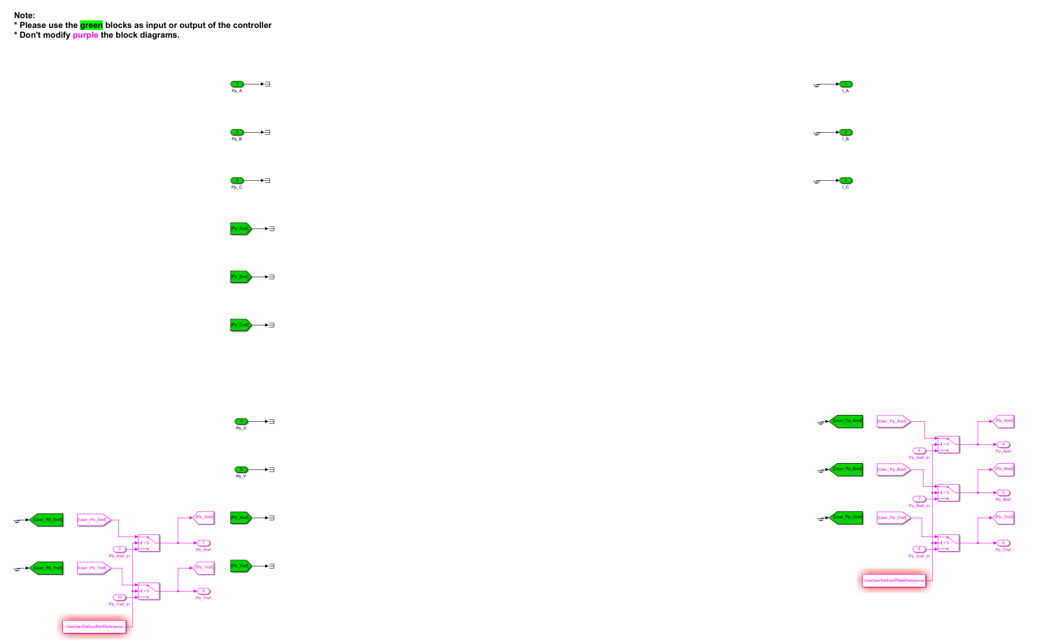
4. By default, the simulation uses the references from the MATLAB script for simulation, or a constant 0 reference for experiments. To modify the references, change it in the MATLAB script (simulation only), or add the output of your own reference generator to the input of a “goto” block named “User_xxx” (example depicted below) within the controller.slx file, where xxx is the name of the parameter. **Note, to use the reference generated in a Simulink file, perform step 10.**  
   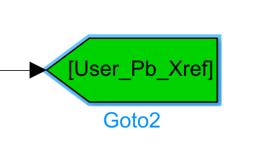
5. Now you are ready to design your controller. All signals that can be measured on the plant, are provided through in/out ports. **Only use the in/out ports (example shown below), as input/output signals for your controller.**
6. Copy and paste the experimentation file “Template_PerformExperiment.m”, which is located in the folder “Experiments”.
7. Give the copy a descriptive name and open it.
8. **Note, don’t change any code in the sections which name end with** (Do not change) **and don’t change lines of code that are followed by** % (Do not change)**.**
9. Update the “controllerFilename”, in the section %% Controller settings, to the name of the controller (see step 2)
10. To use the reference(s) designed in a Simulink file (as mentioned in step 4), change “UseUserDefinedPlateReference” or “UseUserDefinedBallReference” to something else than 0.
11. To change the behavior of the model or measurement, settings can be changed. If settings are missing, contact Mike.

**2. Performing an experiment**

1. Select if you want to use the model, or the setup by modifying “SimulateOrMeasure” (0 for simulating, any other number for measuring).
2. Run the script

If you experience any problems, contact Mike.